**Test 1 **

|  |  |  |  |
| --- | --- | --- | --- |
| TERM | COURSE NAME | COURSE CODE | VERSION |
| Fall | Data Structures and Algorithms | BTP500 | A |

|  |  |
| --- | --- |
| Name | Khai Phan Thanh |
| Student Number | 100901164 |
| Section | NBB |

DATE: Friday, December 11

TIME ALLOWED: 1 hour 45 min

QUESTIONS:

PART A Short/Long Answers 40 MARKS

PART B Programming 20 MARKS

TOTAL MARKS 60 MARKS

PROFESSOR(S): Catherine Leung, Miguel Watler

**SPECIAL INSTRUCTIONS:**

1. Feel free to use all resource material available to you, including sample code from the lectures, labs, assignments, and internet resources.
2. Answer all questions in the spaces provided on the test paper.
3. If you use Visual Studio to test your code, or something else, be sure to copy and paste your code here, or submit your source code separately.

This test includes a *cover page*, plus 12 pages of *questions*.

|  |
| --- |
| SENECA’S ACADEMIC HONESTY POLICY |
| As a Seneca student, you must conduct yourself in an honest and trustworthy manner in all aspects of your academic career. A dishonest attempt to obtain an academic advantage is considered an offense and will not be tolerated by the College. |

PART A

Question 1 [5 marks]: Linked Lists

The drawing below shows the current state of a linked list.



Draw what would happen to the linked list if the following snippet of code were to run. Make sure to show where a, b and c are pointing also.

Node* b = a->prev_

Node* c = a->next_;

b->next_=c;

c->prev_=b;

a->next_=c->next_;

a->prev_=c;

c->next_->prev_=a;

c->next_=a;

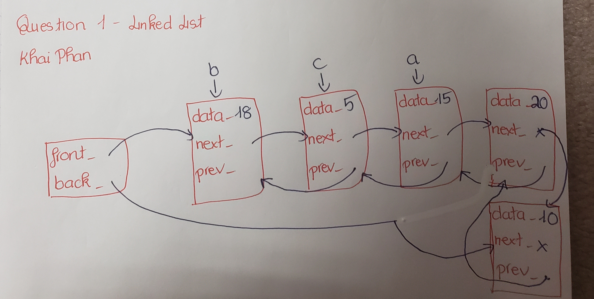

Question 2 [7 marks]: Heaps

Suppose you are given the following array: {3, 8, 5, 2, 7, 6, 4, 9, 1}

Perform the **makeheap** algorithm on the complete binary tree represented by the above array, performing multiple **heapify()** routines to form a **maxheap**. Show the steps and show the result in binary tree form.

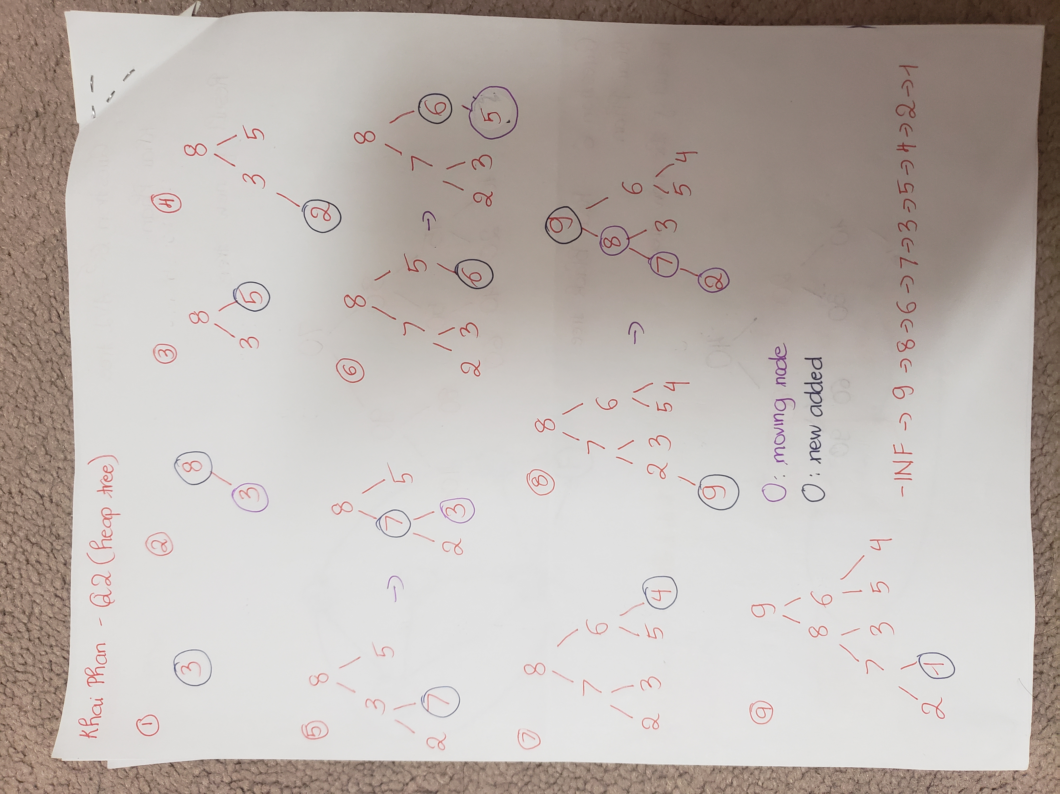

Question 3 [5 marks]: Big-O Analysis

Suppose you are given the following function:

void myfunction(int n){  
       f1(n);  
       for(int i = 0 ;i < n; i += 2){  
              f2(n);  
       }  
}

You are told that f1()'s runtime is linear with respect to n, but you do not know what the runtime of f2() is.

You do some experiments and do some timing runs on myFunction() and find the following results:

|  |  |
| --- | --- |
| n | time in milliseconds |
| 100 | 1 |
| 200 | 4 |
| 300 | 9 |
| 400 | 16 |
| 500 | 25 |
| 600 | 36 |

1. Assuming the timing trend continues, what is runtime of myFunction()? (1 mark )

* The runtime will be O(1). Because it is specify that runtime of f1() is linear and depends on n, the runtime will be O(1) for every n increase

1. Assuming the timing trend continues, what is worst possible runtime of f2()?  Explain why. (4 marks)

* f(2) will have a runtime of O(n). The reason is that it will have to go all the loop for the operation.

Question 4 [4 marks]: Traversals

Given the following diagram:

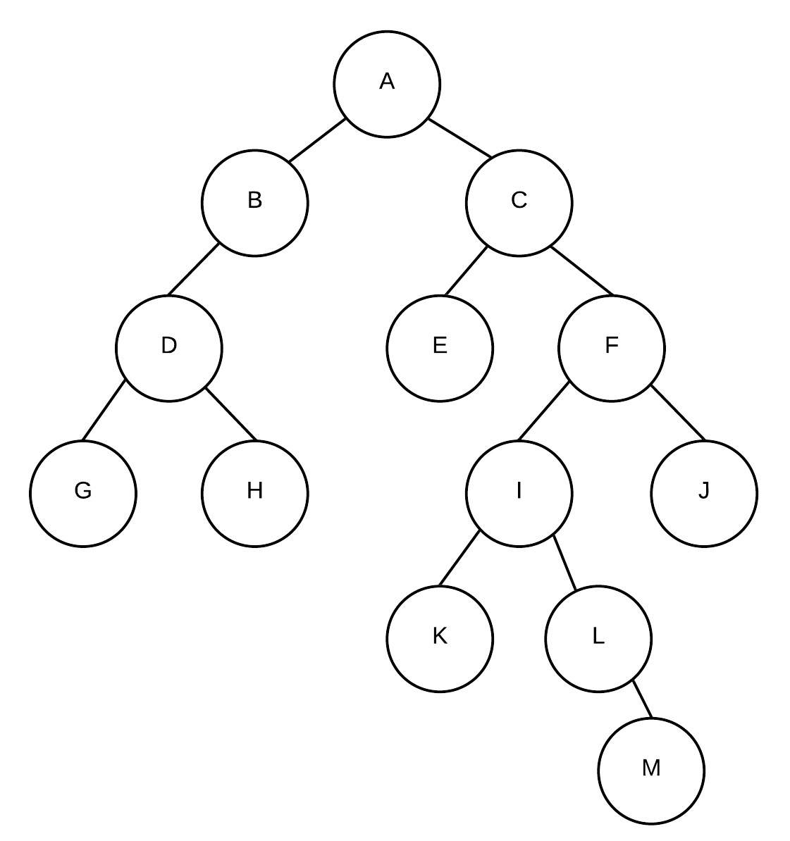

**List the nodes if we were to print every node once in a post-order manner:**

**G 🡪 H 🡪 D 🡪 B 🡪 E 🡪 K 🡪 M 🡪 L 🡪 I 🡪 J 🡪 F 🡪 C 🡪 A**

Question 5 [6 marks]: AVL Trees

Given the below AVL tree, if the value 15 was to be inserted to the above tree, it would require **a double rotation** to make the tree height balanced.

Show and explain the steps and show the resulting tree.

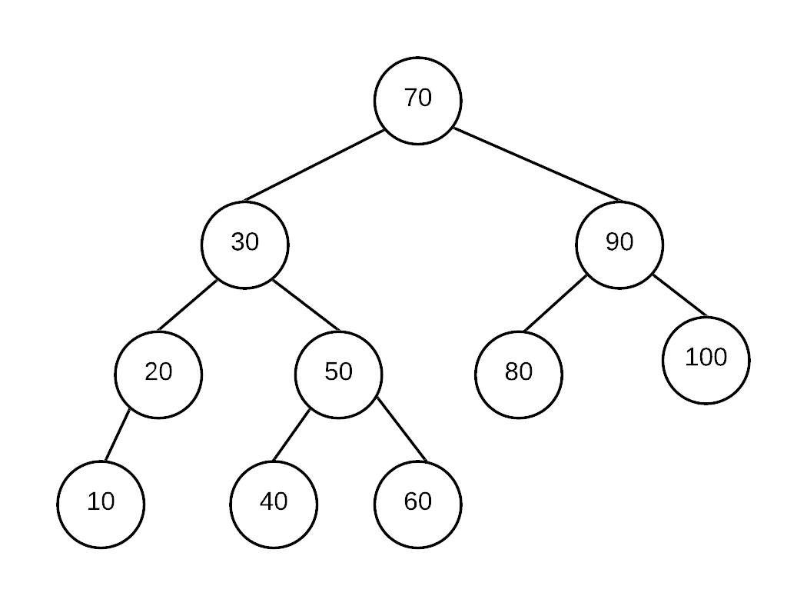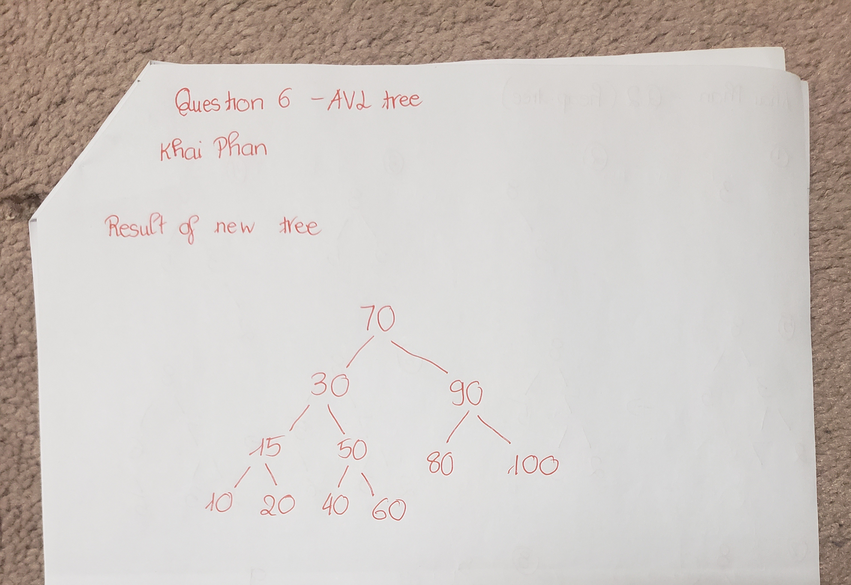

**What happen here is that, when inserting 15, it will be the right node of 10, so we have to perform a first rotation to make 20-10-15 align. We switch the location 10 into 15, then right now 10 will be on the left side of 15 (as 10 is smaller), which is now aligned, then I will push 15 up and pull 20 down so in the end, 10 will stay on the left side of 15 and 20 will be on the right**

Question 6 [5 marks]: Red-Black Trees

Show the resulting tree after inserting 15 into the following Red-Black tree. Show and explain each step.

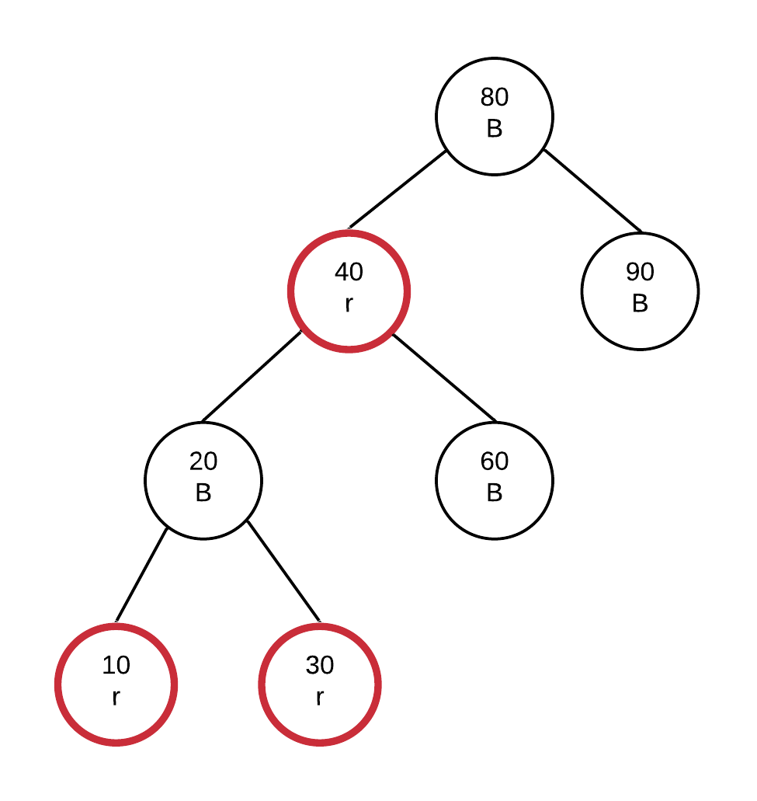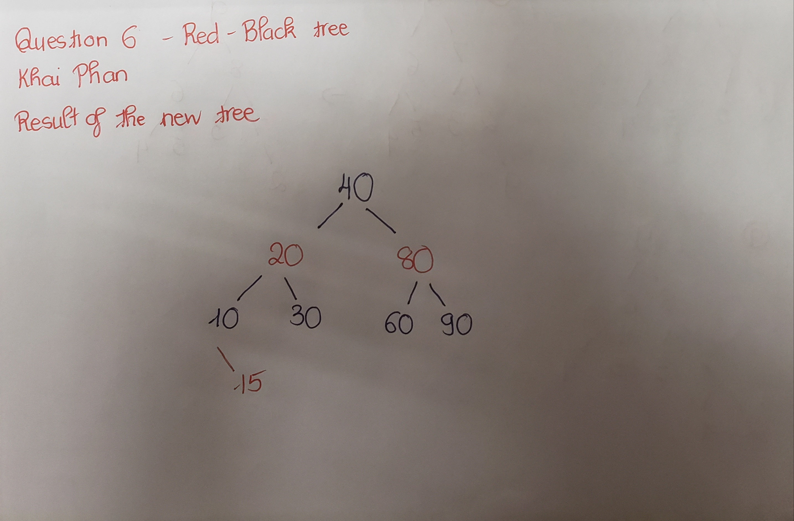

**When 15 is inserting into the tree above, it will be on the right side of 10 with a color of Red. Because Parent and Uncle are all red, we have to push the Red into Grandparent, which is 20. Right now, 15 will remain Red, 10 and 30 will turn Black and 20 will turn Red.**

**Then we need to perform a rotation to make the tree balance. There is a single rotation at 40, which create a new sub-node of 80 on the right, and keep 20 on the left. We also need to relocated 60 as it is now lower than 80 but greater than 40**

Question 7 [4 marks]: Graphs

The following diagram of adjacency list represents a graph.



1. draw the above as a graph. Be sure to label the vertices and directions of edges (3 marks)

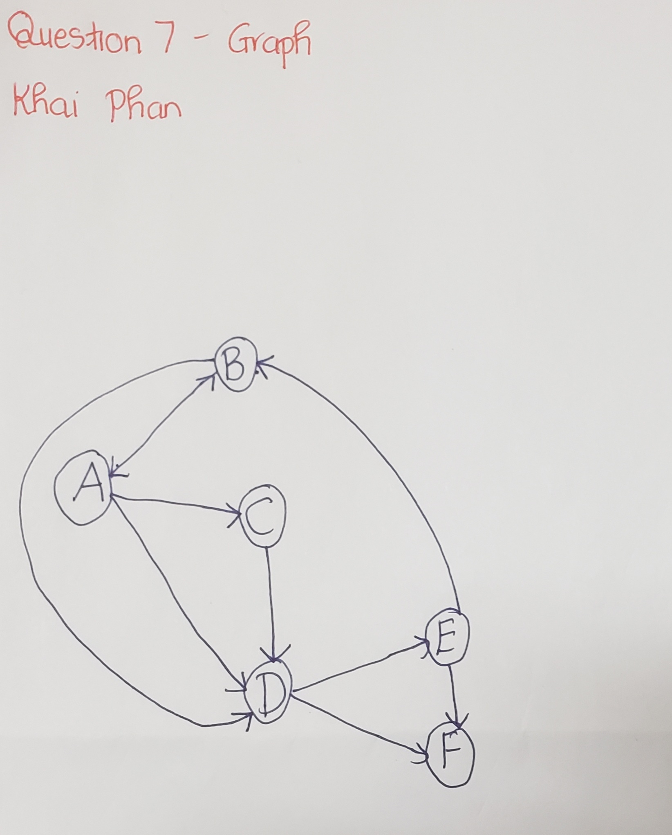

b) If the above graph was represented as an adjacency matrix instead of an adjacency list, how many non-zero entries would be in that matrix? (1 marks)

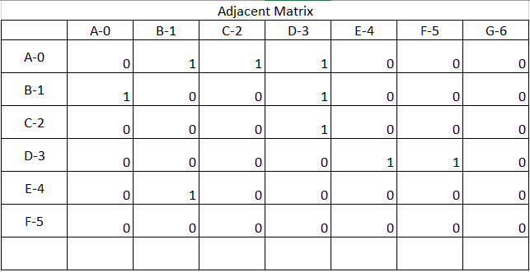

**According to the above table, there are 9 non-zero entries altogether**

Question 8 [4 marks]: Computational Theory

Explain what the "P vs NP" problem is.

* **P (Polynomial): I can find the solution and I can find the solution correctly. Example could be a simple Sorting or Math**
* **NP (Non- deterministic polynomial): I cannot find the solution as it is hard to find, but if answer is given, I can verify the answer. Example could be Vehicle Routing, Job Scheduling, Database Problem, Realistic Example is: It takes sometimes for a computer to solve a sudoku as it has to do through lots of calculation and checking, while if given a completed sudoku, the computer can instantly check if it right or wrong.**

PART B

Question 9 [10 marks]: Binary Trees

Given the following definition of a node and binary search tree, write the member function described below. You may declare and implement more functions if you need but you need to fully code any function you call.  The run time must not exceed O(n).

class BST{  
    struct Node{  
        int data_;  
        Node* left_;  
        Node* right_;  
        Node(int dat){  
            data_=dat;  
            left_=right_=nullptr;  
        }  
    };  
    Node* root_;  
    ...  
};

Write the following member functions of BST:

**int BST::findSmallest(int v);**  
  
Assume the tree is balanced. This function finds smallest value in the subtree defined by the root node containing the value v.  If v is not found function returns -1.  For example, given the following tree:

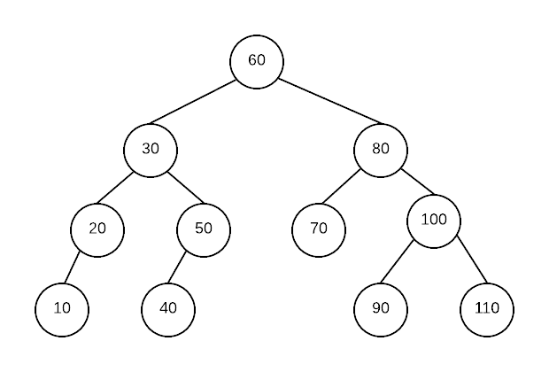

findSmallest(80) would result in 70

findSmallest(30) would return 10

findSmallest(110) would result in 110

findSmallest (55) would result in -1

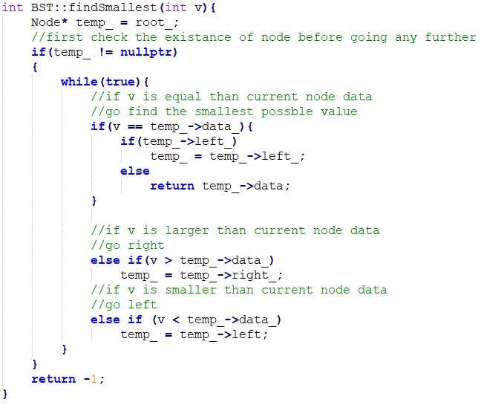

Question 10 [10 marks]: Binary Trees

Given the following definition of a node and binary search tree, write the member function described below. You may declare and implement more functions if you need but you need to fully code any function you call.  To get full marks, this function must have an O(n) run time.

class BST{  
    struct Node{  
        int data_;  
        Node* left_;  
        Node* right_;  
        Node(int dat){  
            data_=dat;  
            left_=right_=nullptr;  
        }  
    };  
    Node* root_;  
    ...  
};

Write the following member functions of BST:

**int BST::count() const;**

* This function returns the total number of nodes in the tree
* Runtime requirement O(n)

For example given the tree below count() would return 11



